EARLY DETECTION OF CHRONIC KIDNEY DISEASE USING MACHINE LEARNING

PROJECT REPORT

Submitted by
Team ID: PNT2022TMID36181
SOWTHAMI M 110519104026
PAVITHRA B 110519104016
POOJA P 110519104017
JENIFER P 110519104009
ASHWINI S 110519104002

In Partial Fulfilment for the Award of the Degree
OF
BACHELOR OF ENGINEERING IN
COMPUTER SCIENCE AND ENGINEERING




GOJAN SCHOOL OF BUSINESS AND TECHNOLOGY REDHILLS.
ANNA UNIVERSITY: CHENNAI – 600 025
NOVEMBER 2022

PROJECT REPORT

EARLY DETECTION OF CHRONIC KIDNEY DISEASE USING
MACHINE LEARNING

- INTRODUCTION:

  - Project Overview
Chronic Kidney Disease (CKD) is a major medical problem and can be cured if treated in the early stages. Usually, people are not aware that medical tests we take for different purposes could contain valuable information concerning kidney diseases. Consequently, attributes of various medical tests are investigated to distinguish which attributes may contain helpful information about the disease. The information says that it helps us to measure the severity of the problem and we make use of such information to build a machine learning model that predicts Chronic Kidney Disease

  - Purpose
- You’ll be able to understand the problem to classify if it is a regression or a classification kind of problem.
- You will be able to know how to pre-process/clean the data using different data pre-processing techniques.
- You will be able to analyze or get insights from data through visualization.
- Applying different algorithms according to the dataset.
- You will be able to know how to find the accuracy of the model.
- You will be able to build web applications using Flask.
- You will be able to know how to build a web application using the Flask framework.

- LITERATURE SURVEY:

  - Existing problem

- People with hypertension, diabetes or cardiovascular disease should be part of early detection programs for CKD.
- Other population-specific risk factors may be used to identify groups that might benefit from targeted detection programs.
- Diabetes and high blood pressure are the most common causes of kidney disease. Your health care provider may do tests to find out why you have kidney disease.
- The cause of your kidney disease may affect the type of treatment you receive.

  - References

[1] A. K. Jha, C. M. DesRoches, E. G. Campbell, K. Donelan, S. R. Rao, T. G. Ferris, A. Shields, S. Rosenbaum, and D. Blumenthal, “Use of electronic health records in US hospitals,” New England Journal of Medicine, vol. 360, no. 16, pp. 1628-1638,.

[2] N. Lee, A. F. Laine, J. Hu, F. Wang, J. Sun, and S. Ebadollahi, “Mining electronic medical records to explore the linkage between healthcare resource utilization and disease severity in diabetic patients,” in HISB, 2011. IEEE, 2011, pp. 250-257.

[3] P. B. Jensen, L. J. Jensen, and S. Brunak, “Mining electronic health records: towards better research applications and clinical care,” Nature reviews. Genetics, vol. 13, no. 6, p. 395.

[4] K. Kowsari, K. Jafari Meimandi, M. Heidarysafa, S. Mendu, L. Barnes, and D. Brown, “Text classification algorithms: A survey,” Information, vol. 10, no. 4, p. 150.

[5] A. S. Levey and J. Coresh, “Chronic kidney disease,” The lancet, vol. 379, no. 9811, pp. 165- 180.

[6] A. S. Levey, J. Coresh, E. Balk, A. T. Kausz, A. Levin, M. W. Steffes, R. J. Hogg, R. D. Perrone, J. Lau, and G. Eknoyan, “National kidney foundation practice guidelines for chronic kidney disease: evaluation, classification, and stratification,” Annals of internal medicine, vol. 139, no. 2, pp. 137-147.

[7] Mayo Clinic, “Chronic kidney disease,” http://www.mayoclinic.org/ diseases-conditions/chronic-kidney-disease/home/ovc-20207456.

[8] National Institute of Diabetes and Digestive and Kidney Diseases, “Kidney disease statistics for the United States,” https://www.niddk.nih.gov/ health-information/health-statistics/kidney-disease.

[9] V. Jha, G. Garcia-Garcia, K. Iseki, Z. Li, S. Naicker, B. Plattner, R. Saran, A. Y.-M. Wang, and C.-W. Yang, “Chronic kidney disease: global dimension and perspectives,” The Lancet, vol. 382, no. 9888, pp. 260-272.

[10] N. R. Hill, S. T. Fatoba, J. L. Oke, J. A. Hirst, C. A. O’Callaghan, D. S. Lasserson, and F. R. Hobbs, “Global prevalence of chronic kidney disease-a systematic review and meta-analysis,” PLoS One, vol. 11, no. 7, p. e0158765.

  - Problem Statement Definition
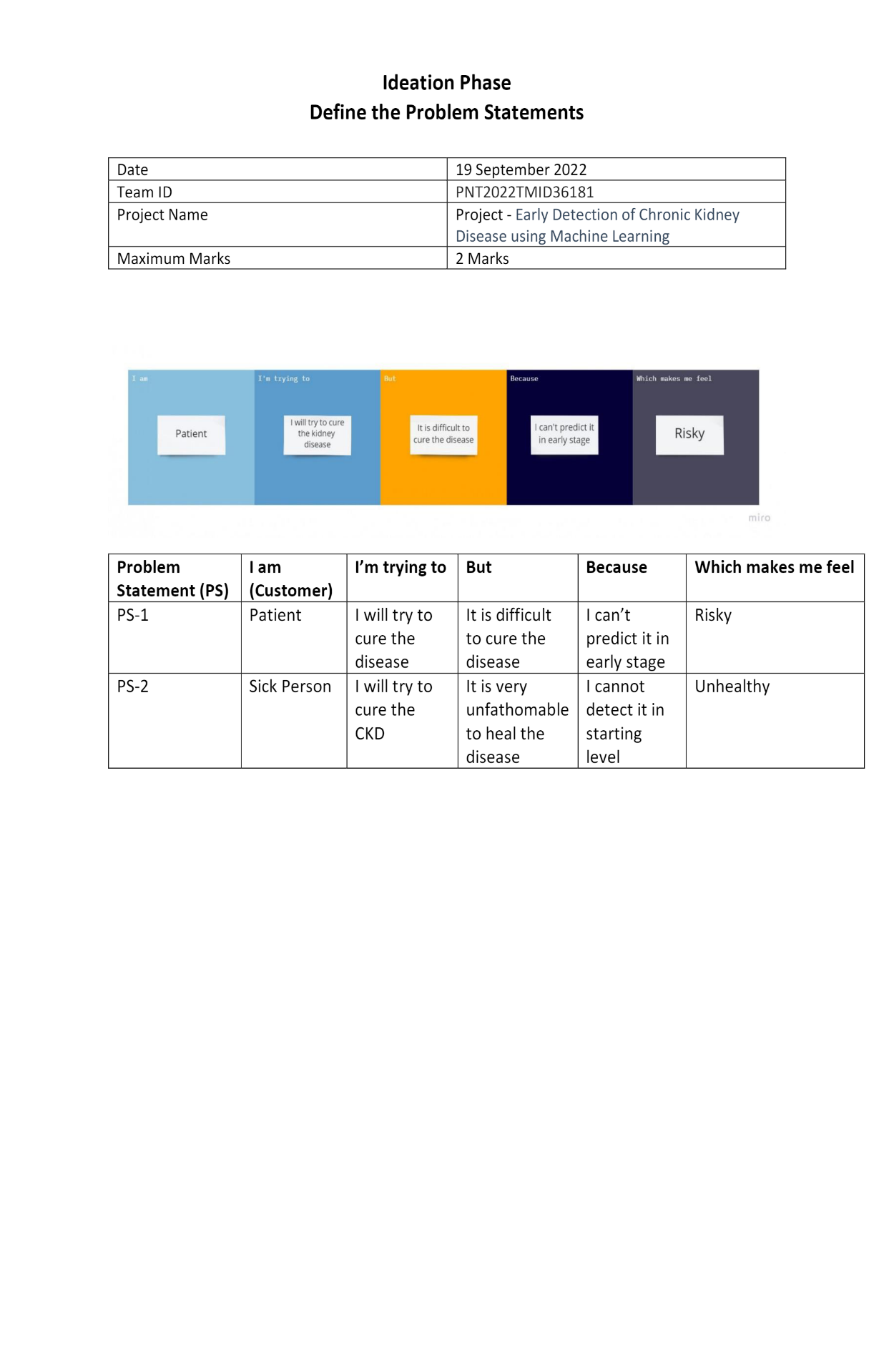

- IDEATION & PROPOSED SOLUTION:

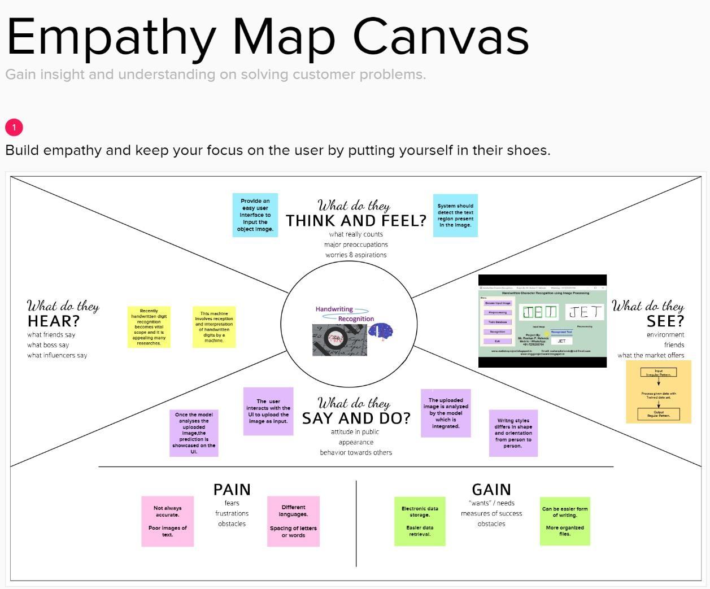
  - Empathy Map Canvas

  - Ideation & Brainstorming

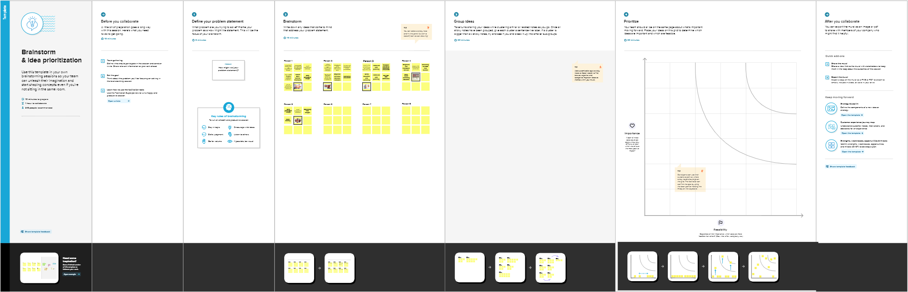

  - Proposed Solution

S.No | Parameter | Description
1. | Problem Statement (Problem to be solved) | Predicting the early detention of chronic kidney disease using machine learning will able to find the problem and analyse the regression with the help of different data preprocessing techniques.
2. | Idea / Solution description | Using a preprocessing techniques will be able to analyze or get insights overview from data through visualization. In order to train the machine with pre-processed data with an algorithm to build a model.
3. | Novelty / Uniqueness | In Machine Learning the dataset which will be used in the training phase is a very important point to build a successful prediction for the early chronic kidney disease.
4. | Social Impact / Customer Satisfaction | Early detection of Chronic Kidney Disease in its initial stages can help the patient get effective treatment and then prohibit the progression to End Stage Renal Disease.
5. | Business Model (Revenue Model) | The construction of the model capable of classifying the possibility of a diagnosis of chronic kidney disease with an accuracy of 93%.
6. | Scalability of the Solution | The study concluded that, the impact of obtaining a diagnosis in less time to treat the disease in early stages , reducing cost in health system.

  - Problem Solution fit

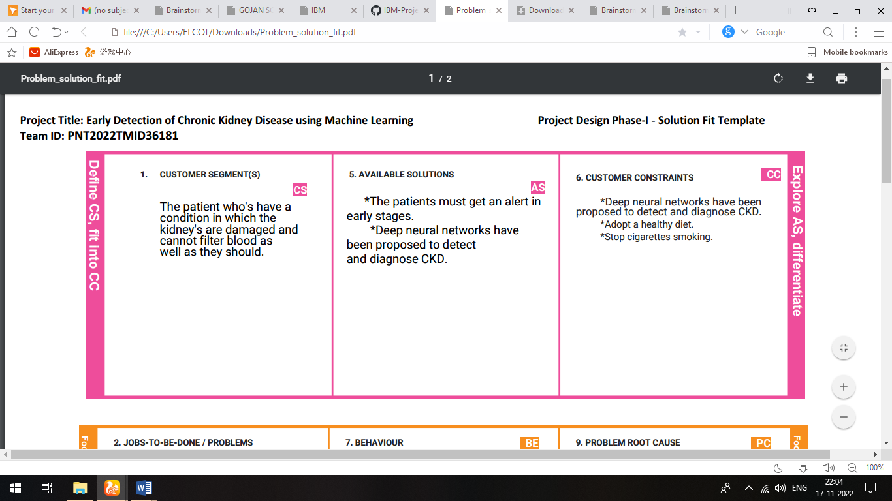

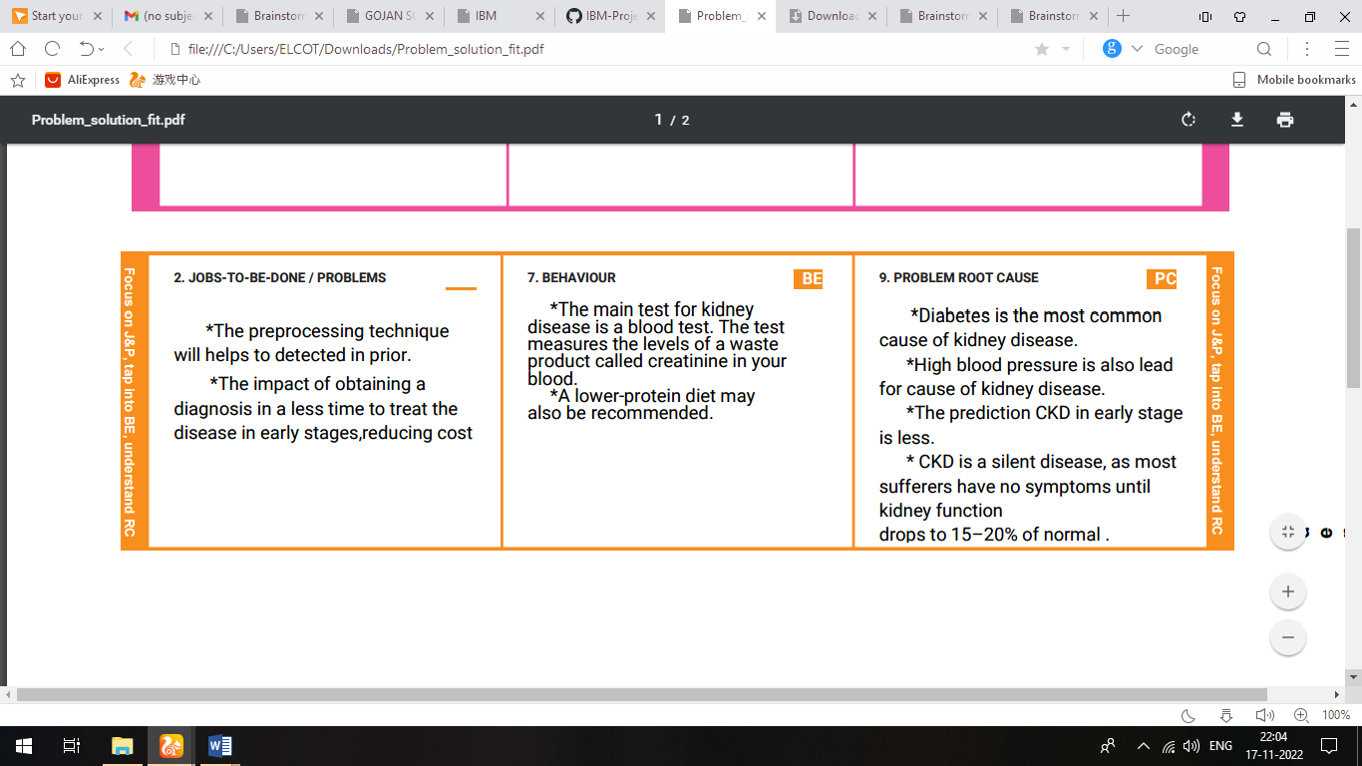
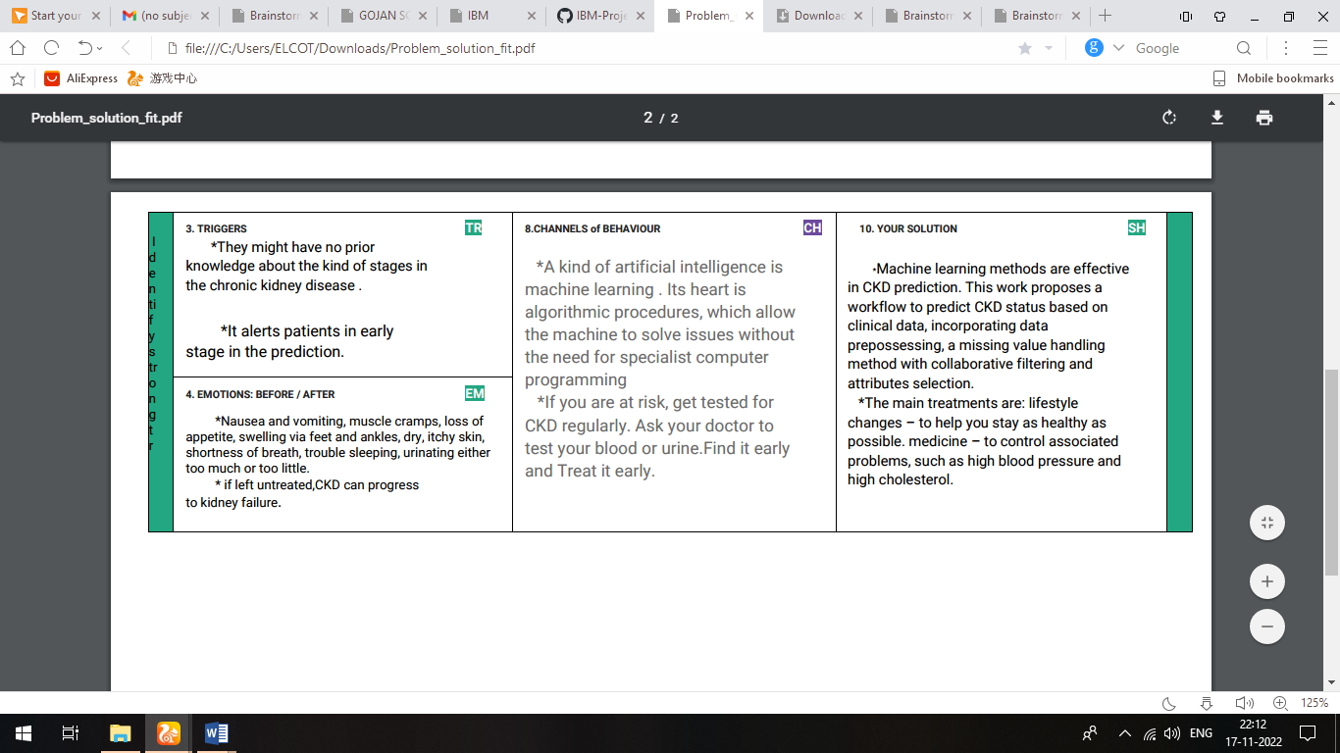

- REQUIREMENT ANALYSIS:

  - Functional requirements

FR No. | Functional Requirement (Epic) | Sub Requirement (Story / Sub-Task)
FR-1 | User Registration. | Registration through Form  Registration through Gmail  Registration through Linked IN
FR-2 | User Confirmation. | Confirmation via Email  Confirmation via OTP

FR-3 | Website comparison | Model compares the websites using Blacklist and Whitelist approach
FR-4 | Prediction | Model predicts the URL using machine learning
FR-5 | Classifier | Model sends all the output to classifier and produces final results
FR-6 | Events | The quality of retrieving is needed in this model and displaying the result for a website

  - Non-Functional requirements

FR No. | Non-Functional Requirement | Description
NFR-1 | Usability | User can have rights to access to the particular websites must be proceed and the some certain user friendly websites so it does not affect the data’s.
NFR-2 | Security | To check whether the particular website is secure or not secure
NFR-3 | Reliability | It must be a reliable source to the users while they using the websites
NFR-4 | Performance | The performance must be good while using the websites which the users proceeds the websites.
NFR-5 | Availability | The website availability must be valid for the users to access the resource
NFR-5 | Scalability | It must be able to handle an increases in users and loads without disrupting the end users

- PROJECT DESIGN:

  - Data Flow Diagrams

A Data Flow Diagram (DFD) is a traditional visual representation of the information flows within a system. A neat and clear DFD can depict the right amount of the system requirement graphically. It shows how data enters and leaves the system, what changes the information, and where data is stored.

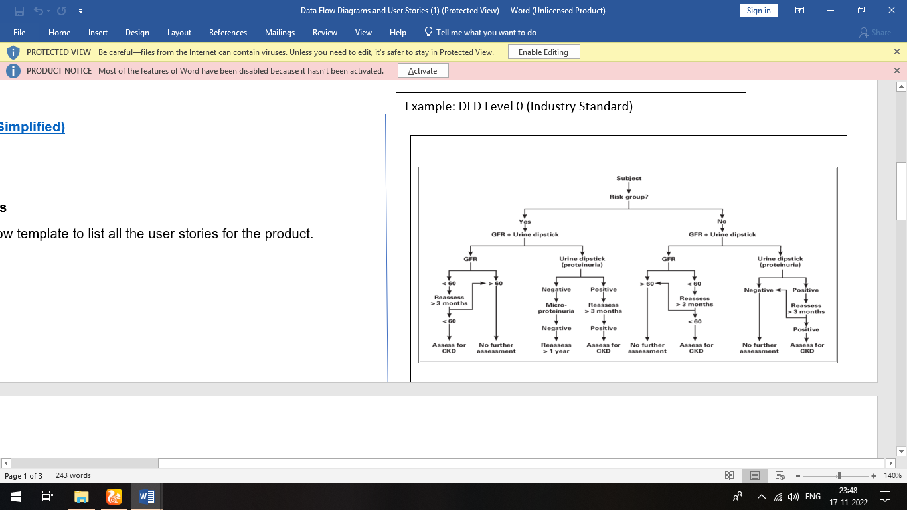

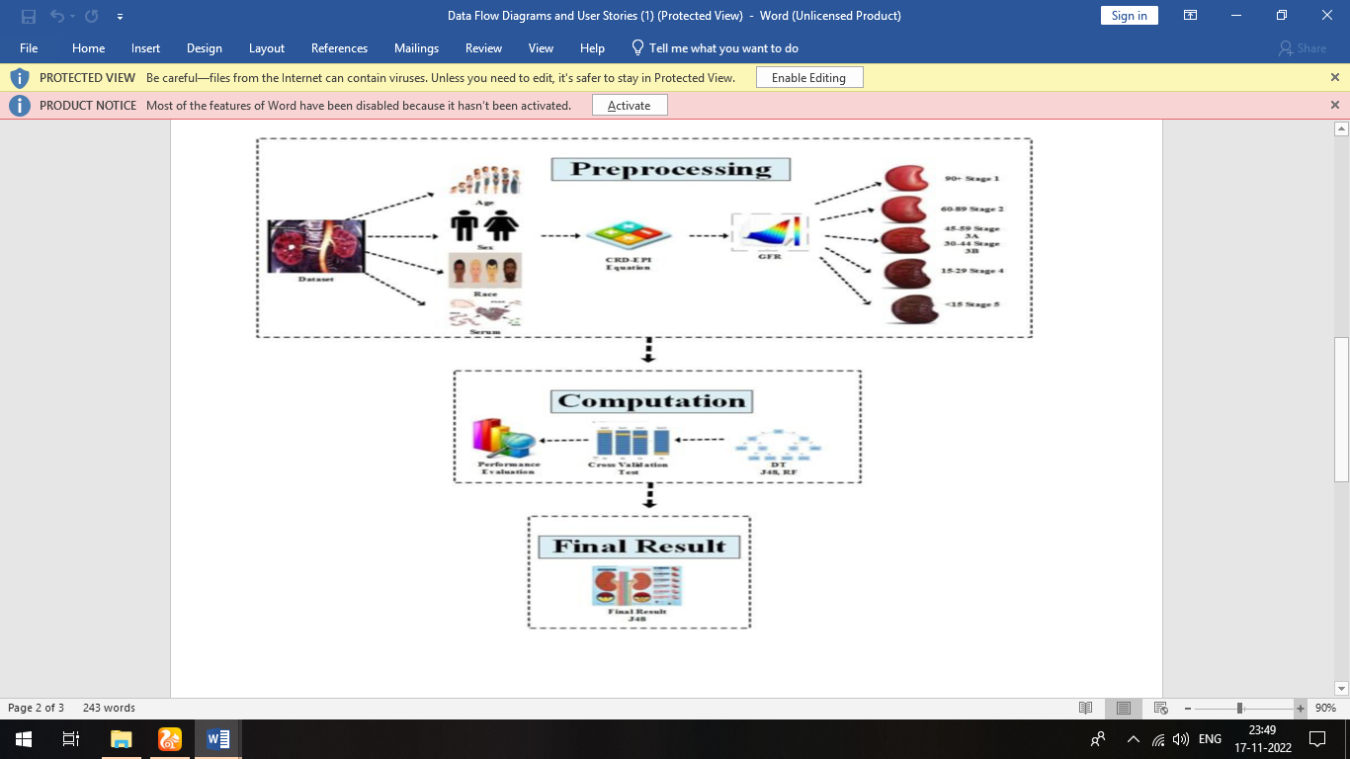

  - Solution & Technical Architecture
Technology Architecture

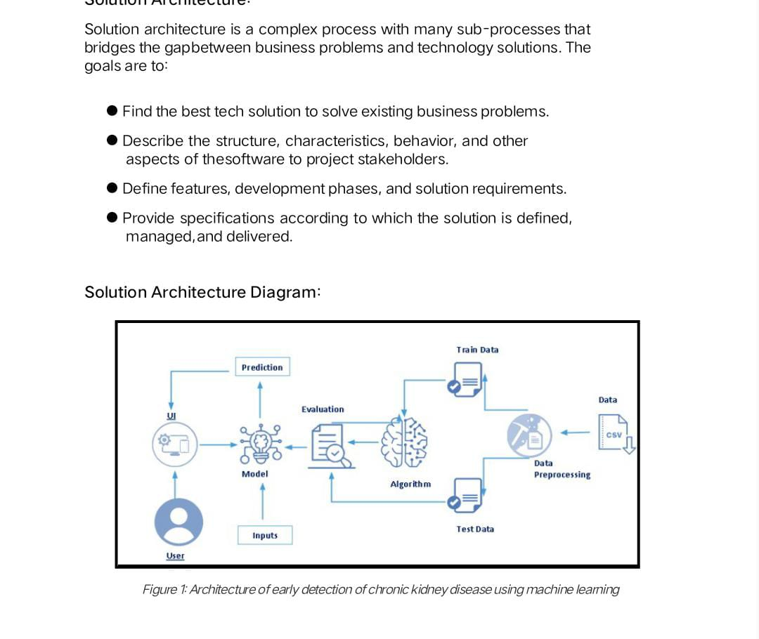

Solution Architecture:
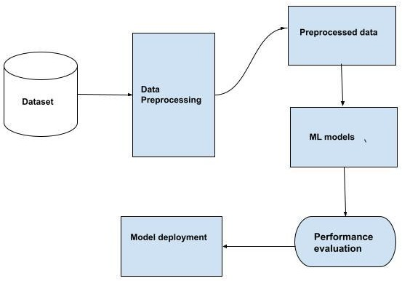

  - User Stories :

User Type | Functional Requirement  (Epic) | User Story  Number | User Story / Task | Acceptance criteria | Priority | Release
Patient | Registration | USN-1 | To register the diagnosis.  Email confirmation.  Login to the diagnosis tool. | I can see the information regarding  The registration. | High | Sprint 1
Patient | Login | USN-2 | Filling form for pre-diagnostic test results.  Feature of detect CKD.  Choose the suitable Machine learning model. | I can see the login button. | High | Sprint 2
Patient | Dashboard | USN-3 | To view past records.  Generated test report.  Remedies to treat the symptoms. | I can see the dashboard. | High | Sprint 3
Patient | Predict | USN-4 | Register into Gmail  User queries form  User feedback form | Filling the details about patient and queries form. | High | Sprint 4

- PROJECT PLANNING & SCHEDULING:

  - Sprint Planning & Estimation:

Sprint | Functional Requirement (Epic) | User Story Number | User Story / Task
Sprint-1 | Registration | USN-1 | User can register the diagnosis tool by entering an email and password and receives confirmation of email finally registration can applied.

Sprint-1 | Login | USN-2 | User can log into the application by using email and password.
Sprint-1 | Dashboard | USN-3 | User can see their past records and activities
Sprint-2 | Entry form | USN-4 | User must enter the pre-diagnosis test results

Sprint-2 | Report | USN-5 | User can view the report generations using the diagnosis tools
Sprint-2 | Features | USN-6 | Administrator should identify the most accurate factors that helps to lead the chronic kidney disease based on the trend
Sprint-3 | Queries | USN-7 | Customers caring executive that should face problems through Q&A
Sprint-3 | Remedies | USN-8 | User receives the remedies to treat the disease
Sprint-4 | Feedback | USN-9 | Customer care executive to tools enhancement.
Sprint-4 | Train model | USN-10 | Administrator must use the most significant ML model for CKD detection

  - Sprint Delivery Schedule :

Sprint | Total Story Points | Duration | Sprint Start Date | Sprint End Date (Planned) | Sprint Release Date (Actual)
Sprint-1 | 20 | 6 Days | 24 Oct 2022 | 29 Oct 2022 | 29 Oct 2022
Sprint-2 | 20 | 6 Days | 31 Oct 2022 | 05 Nov 2022 | 05 Nov 2022
Sprint-3 | 20 | 6 Days | 07 Nov 2022 | 12 Nov 2022 | 12 Nov 2022
Sprint-4 | 20 | 6 Days | 14 Nov 2022 | 19 Nov 2022 | - Nov 2022

  - Reports from JIRA :

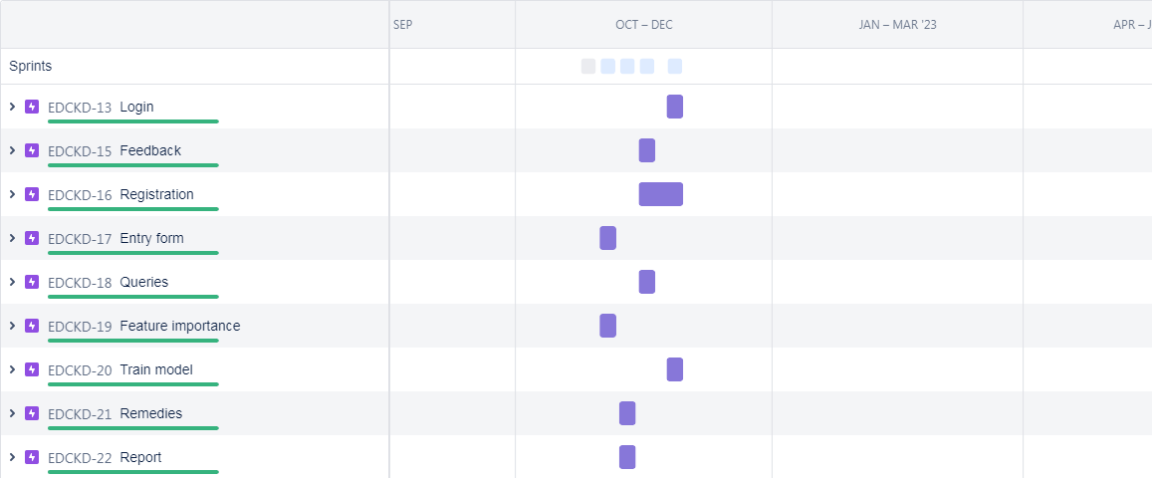

- CODING & SOLUTIONING:

  - Feature 1:
App.py

from flask import Flask,render_template,request
import pandas as pd
import numpy as np #importing necessary modules...
import pickle

app=Flask(__name__) #initializing a flask app
model=pickle.load(open('CKD.pkl','rb')) #loading model

@app.route('/')
def home():
return render_template('index.html') #rendering a index page

@app.route('/home',methods=['POST','GET'])
def index():
return render_template('home.html') #rendering an home page

@app.route('/predict',methods=['POST','GET'])
def predict():
return render_template('predict.html') #rendering a prediction page

@app.route('/backindex',methods=['POST','GET'])
def backindex():
return render_template('index.html') #rendering back to the indexpage

@app.route('/backhome',methods=['POST','GET'])
def backhome():
return render_template('home.html') #rendering back to the homepage

@app.route('/result',methods=['POST']) #rendering prediction button
def result():
input_features=[float(x) for x in request.form.values()]
features_value=[np.array(input_features)]
features_name=['blood_urea','blood_glucose_random','coronary_artery_disease','anemia','pus_cell','red_blood_cells','diabetesmellitus',
'pedal_edema']

df=pd.DataFrame(features_value,columns=features_name)
output=model.predict(df) #predicting with the help of model
b=[1]
if output==b:
return render_template("result1.html")
else:
return render_template("result2.html")

if __name__=="__main__": # Running our app
app.run(debug=True)

  - Feature 2 :

Model building (Clean the data)

import pandas as pd
import numpy as np
from sklearn.model_selection import train_test_split
from sklearn.linear_model import LogisticRegression
from sklearn.metrics import accuracy_score, confusion_matrix
from sklearn.preprocessing import LabelEncoder
from collections import Counter as c
import pickle

data=pd.read_csv('chronickidneydisease.csv') #dataframe
data.drop(['id'],axis=1,inplace=True) #dropping id column

data.columns.values[1]="blood_pressure"
data.columns.values[2]="specific_gravity"
data.columns.values[3]="albumin"
data.columns.values[4]="sugar"
data.columns.values[5]="red_blood_cells"
data.columns.values[6]="pus_cell"
data.columns.values[7]="pus_cell_clumps"
data.columns.values[8]="bacteria"
data.columns.values[9]="blood_glucose_random"
data.columns.values[10]="blood_urea"
data.columns.values[11]="serum_creatinine"
data.columns.values[12]="sodium"
data.columns.values[13]="potassium"
data.columns.values[14]="hemoglobin"
data.columns.values[15]="packed_cell_volume"
data.columns.values[16]="white_blood_cell_count"
data.columns.values[17]="red_blood_cell_count"
data.columns.values[18]="hypertension"
data.columns.values[19]="diabetesmellitus"
data.columns.values[20]="coronary_artery_disease"
data.columns.values[21]="appetite"
data.columns.values[22]="pedal_edema"
data.columns.values[23]="anemia"
data.columns.values[24]="class"

# replacing ckd\t to ckd(chronic kidney disease)
data['class']=data['class'].replace("ckd\t","ckd")

# selecting object data dype
catcols=set(data.dtypes[data.dtypes=="O"].index.values)
catcols.remove('red_blood_cell_count')
catcols.remove('packed_cell_volume')
catcols.remove('white_blood_cell_count')

# Excluding object data type
contcols=set(data.dtypes[data.dtypes!="O"].index.values)
contcols.remove('specific_gravity')
contcols.remove('albumin')
contcols.remove('sugar')

contcols.add('red_blood_cell_count')
contcols.add('packed_cell_volume')
contcols.add('white_blood_cell_count')

catcols.add('specific_gravity')
catcols.add('albumin')
catcols.add('sugar')

data['coronary_artery_disease']=data.coronary_artery_disease.replace('\tno','no')
data['diabetesmellitus']=data.diabetesmellitus.replace(to_replace={'\tno':'no','\tyes':'yes','yes':'yes'})

data.packed_cell_volume=pd.to_numeric(data.packed_cell_volume,errors='coerce')
data.white_blood_cell_count=pd.to_numeric(data.white_blood_cell_count,errors='coerce')
data.red_blood_cell_count=pd.to_numeric(data.red_blood_cell_count,errors='coerce')

# Replacing the missing values by finding mean

data['blood_glucose_random'].fillna(data['blood_glucose_random'].mean(),inplace=True)
data['blood_pressure'].fillna(data['blood_pressure'].mean(),inplace=True)
data['blood_urea'].fillna(data['blood_urea'].mean(),inplace=True)
data['hemoglobin'].fillna(data['hemoglobin'].mean(),inplace=True)
data['packed_cell_volume'].fillna(data['packed_cell_volume'].mean(),inplace=True)
data['potassium'].fillna(data['potassium'].mean(),inplace=True)
data['red_blood_cell_count'].fillna(data['red_blood_cell_count'].mean(),inplace=True)
data['serum_creatinine'].fillna(data['serum_creatinine'].mean(),inplace=True)
data['sodium'].fillna(data['sodium'].mean(),inplace=True)
data['white_blood_cell_count'].fillna(data['white_blood_cell_count'].mean(),inplace=True)

# Replacing the missing values by finding mode

data['age'].fillna(data['age'].mode()[0],inplace=True)
data['hypertension'].fillna(data['hypertension'].mode()[0],inplace=True)
data['pus_cell_clumps'].fillna(data['pus_cell_clumps'].mode()[0],inplace=True)
data['appetite'].fillna(data['appetite'].mode()[0],inplace=True)
data['albumin'].fillna(data['albumin'].mode()[0],inplace=True)
data['pus_cell'].fillna(data['pus_cell'].mode()[0],inplace=True)
data['red_blood_cells'].fillna(data['red_blood_cells'].mode()[0],inplace=True)
data['coronary_artery_disease'].fillna(data['coronary_artery_disease'].mode()[0],inplace=True)
data['bacteria'].fillna(data['bacteria'].mode()[0],inplace=True)
data['anemia'].fillna(data['anemia'].mode()[0],inplace=True)
data['sugar'].fillna(data['sugar'].mode()[0],inplace=True)
data['diabetesmellitus'].fillna(data['diabetesmellitus'].mode()[0],inplace=True)
data['pedal_edema'].fillna(data['pedal_edema'].mode()[0],inplace=True)
data['specific_gravity'].fillna(data['specific_gravity'].mode()[0],inplace=True)

# label Encoding
for i in catcols:
LEi=LabelEncoder()
data[i]=LEi.fit_transform(data[i])

# Spliting Dataset into independent and dependent variables

selcols=['blood_urea','blood_glucose_random','coronary_artery_disease','anemia','pus_cell','red_blood_cells','diabetesmellitus',
'pedal_edema']
x=pd.DataFrame(data,columns=selcols)
y=pd.DataFrame(data,columns=['class'])

x_train,x_test,y_train,y_test=train_test_split(x,y,test_size=0.2,random_state=2)

lgr=LogisticRegression()
lgr.fit(x_train,y_train)

y_pred=lgr.predict(x_test)
y_pred1=lgr.predict([[129,99,1,0,0,1,0,1]])

accur=accuracy_score(y_test,y_pred)

conf=confusion_matrix(y_test,y_pred)
print(conf)

model=pickle.dump(lgr,open('CKD.pkl','wb'))

- TESTING:

  - Test Cases

This report shows the number of test cases that have passed, failed, and untested.

Section | Total Cases | Not Tested | Fail | Pass
Print Engine | 7 | 0 | 0 | 7
Client Application | 51 | 0 | 0 | 51
Security | 2 | 0 | 0 | 2
Outsource Shipping | 3 | 0 | 0 | 3
Exception Reporting | 9 | 0 | 0 | 9
Final Report Output | 4 | 0 | 0 | 4
Version Control | 2 | 0 | 0 | 2

  - User Acceptance Testing

The purpose of this document is to briefly explain the test coverage and open issues of the [Product Name] project at the time of the release to User Acceptance Testing (UAT).

This report shows the number of resolved or closed bugs at each severity level, and how they were resolved

Resolution | Severity 1 | Severity 2 | Severity 3 | Severity 4 | Subtotal
By Design | 10 | 4 | 2 | 3 | 20
Duplicate | 1 | 0 | 3 | 0 | 4
External | 2 | 3 | 0 | 1 | 6
Fixed | 11 | 2 | 4 | 20 | 37
Not Reproduced | 0 | 0 | 1 | 0 | 1
Skipped | 0 | 0 | 1 | 1 | 2
Won't Fix | 0 | 5 | 2 | 1 | 8
Totals | 24 | 14 | 13 | 26 | 77

- RESULTS:

  - Performance Metrics

Project team shall fill the following information in model performance testing template.

S .No | Parameter | Values | Screenshot
 | Model Summary | Output 1-  Output 2- | 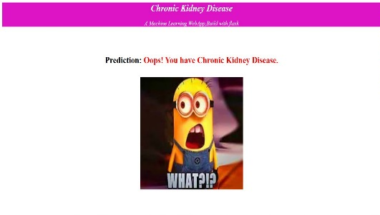  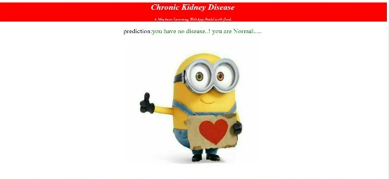
2. | Accuracy | Training Accuracy -  Validation Accuracy - | 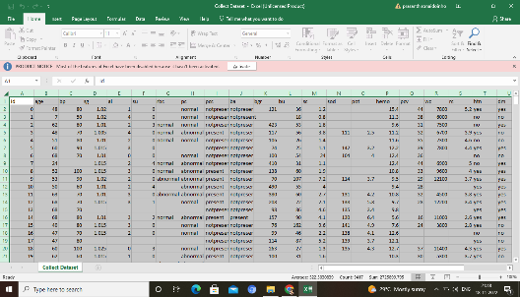  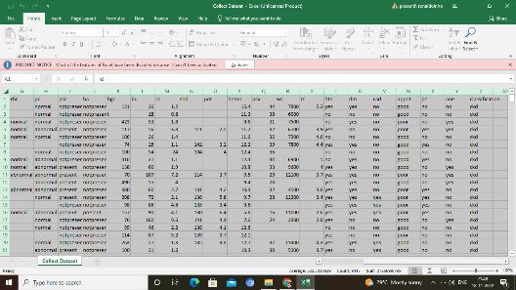

- ADVANTAGES & DISADVANTAGES:

ADVANTAGES
- Regulate the body's fluid levels.
- Filter wastes and toxins from the blood.
- Release a hormone that regulates blood pressure.
- Activate vitamin D to maintain healthy bones.
- Release the hormone that directs production of red blood cells.
- Keep blood minerals in balance (sodium, phosphorus, potassium)

DISADVANTAGES

    - Chronic kidney disease includes conditions that damage your kidneys

    - It decrease their ability to keep you healthy by filtering wastes from your blood.

    - If kidney disease worsens, wastes can build to high levels in your blood and make you feel sick.

    - You may develop complications like: high blood pressure.

- CONCLUSION :

This work examines the ability to detect CKD using machine learning algorithms while considering the least umber of tests or features. We approach this aim by applying four machine learning classifiers: logistic regression, SVM, Random forest, and gradient boosting on a small dataset of 400 records. In order to reduce the number of features and remove redundancy, the association between variables have been studied. A filter feature selection method has been applied to the remaining attributes and found that there are hemoglobin, albumin, and specific gravity have the most impact to predict.

- FUTURE SCOPE:

After defining chronic kidney disease (CKD), discussing the classification of CKD, and defining end-stage renal disease (ESRD), this chapter look at the problems with international comparisons of ESRD data before covering the prevalence of CKD in Western countries, Asian countries, and in developing countries, and the incidence of CKD in Western countries and in ethnic minorities in the West.

It also covers the prevalence and incidence of treated ESRD, and the global cost of CKD and ESRD

- APPENDIX:

Html and CSS

1, ABOUT

<!DOCTYPE html>
<html>
<head>
<title>About</title>
<style>
#p{
text-indent:30px;
font-size:25px;
text-align:justify;
word-spacing:20px;
font-style:oblique;
background-image:radial-gradient(green,yellow,red);
box-shadow:2px 2px 2px black;
}
h1{
text-transform:capitalize;
color:black;
text-shadow:2px 2px 3px yellow;
}
#p2{
text-indent:30px;
font-size:25px;
text-align:justify;
word-spacing:20px;
font-style:oblique;
background-color:yellow;
box-shadow:2px 2px 2px black;
}

</style>
</head>
<body>
<h1>chornic kidney disease:</h1>
<br>
<a href="/backindex"><img src="static/button.jpg" alt="img" width="50px" height="50px"/></a>
<div id="p">
<p>
Chronic Kidney Disease (CKD) is a major medical problem and can be cured if treated in
the early stages. Usually, people are not aware that medical tests we take for different
purposes could contain valuable information concerning kidney diseases. Consequently, attributes
of various medical tests are investigated to distinguish which attributes may contain helpful information
about the disease. The information says that it helps us to measure the severity of the problem and we make use of
such information to build a machine learning model that predicts Chronic Kidney Disease
</p>
</div><br>
<div id="p2">

<p>
In increasingly busy life kidney disease are grooming as pandemic in our society. By developing the
application we provide them appropriate solution by user given dataset.
</p>
</div>
</body>
</html>

2, HOME

!DOCTYPE html>
<html>
<head>
<title>Home page</title>
<style>
body{
background:url("static/kid.jpg");
background-size:cover;
}
.c{
color:blue;
text-align:right;
padding:25px;
}
a[target=blank]{
color:black;
}
h3{
text-align: center;
color:azure;
text-shadow:2px 2px 3px darkred;
font-size:25px;
}
</style>
</head>
<body>
<div class="c">
<nav>
<a href="/home" target="blank">Home</a>
<a href="/predict" target="blank">prediction</a>
</nav>
</div>
<br>
<br>
<br>
<br>
<h3>CHRONIC KIDNEY DISEASE</h3>
<h3>PREDICTION</h3>
</body>
</html>

3, PREDICT

<!DOCTYPE html>
<html>
<head>
<title>disease prediction</title>
<style>
#a{
text-align:left;
padding:15px;
}
a[target=blank]{
color:red;
}
#u{
background-image:linear-gradient(blueviolet,darkmagenta);
height:100px;
width:auto;
text-align:center;
font-style:oblique;
color:azure;
}
[title=b]{
box-shadow:25px black;
position:relative;
color:azure;
background-color:purple;
border-radius:30px;
font-size:15px;
text-align:center;
width:100px;
height:30px;
}
[title=n1]{
width:500px;
}
[title=n]{
width:510px;
}
</style>
</head>
<body>
<div>
<h1 id="u">chornic kidney disease</h1>
<a id="a" href="/backhome" target="_self"><img src="static/button.jpg" width="50px" height="50px" /></a>
</div>
<br>
<form action="/result" method="post">
<center>
<select title="n" name="blood_urea" required>
<option value="" disabled selected hidden>select blood_urea is normal or not..</option>
<option value="0">ubnormal</option>
<option value="1">normal</option>
</select><br><br>
<select title="n" name="blood_glucose_random" required>
<option value="" disabled selected hidden>select blood_glucose_random is normal or not..</option>
<option value="0">ubnormal</option>
<option value="1">normal</option>
</select><br><br>
<select title="n" name="coronary_artery_disease" required>
<option value="" disabled selected hidden>select coronary artery desease or not..</option>
<option value="0">yes</option>
<option value="1">no</option>
</select><br><br>
<select title="n" name="anemia" required>
<option value="" disabled selected hidden>select anemia or not..</option>
<option value="0">yes</option>
<option value="1">no</option>
</select><br><br>
<select title="n" name="pus_cell"required>
<option value="" disabled selected hidden>select pus_cell or not..</option>
<option value="0">yes</option>
<option value="1">no</option>
</select><br><br>
<select title="n" name="red_blood_cells"required>
<option value="" disabled selected hidden>select red_blood_cells level normal or not..</option>
<option value="0">ubnormal</option>
<option value="1">Normal</option>
</select><br><br>
<select title="n" name="diabetesmellitus"required>
<option value="" disabled selected hidden>select diabetesmellitus or not..</option>
<option value="0">yes</option>
<option value="1">no</option>
</select><br><br>
<select title="n" name="pedal_edema"required>
<option value="" disabled selected hidden>select pedal edema or not..</option>
<option value="0">yes</option>
<option value="1">no</option>
</select><br><br>

<input title="b" type="submit" value="prediction"/>
</center>
</form>
</body>
</html>

4, RESULT 1

<!DOCTYPE html>
<html>
<head>
<title>pred page</title>
<style>
#b{
background-color:rgb(220, 20, 197);
color:azure;
font-style:italic;
text-align:center;
}
p{
font-size:20px;
}
h4{
font-size:30px;
}
</style>
</head>
<body>
<div id="b">
<h1>Chronic Kidney Disease</h1>
<p>A Machine Learning WebApp,Build with flask</p>
</div>
<br><br>
<center>
<h4><span style="color:black;">Prediction:</span> <span style="color:red;">Oops! You have Chronic Kidney Disease.</span></h4>
<img src="static/emoj.jpg" alt="img" width="400" height="380"/>
</center>
</body>
</html>

5, RESULT 2

<!DOCTYPE html>
<html>
<head>
<title>Result page</title>
<style>
#b{
background-color:red;
color:azure;
font-style:italic;
text-align:center;
}
#p1{
text-align:center;
font-size:25px;
color:green;
}
</style>
</head>
<body>
<div id="b">
<h1>Chronic Kidney Disease</h1>
<p>A Machine Learning WebApp,Build with flask</p>
</div>
<center>
<p id="p1"><span style="color:black;">prediction:</span>you have no disease..! you are Normal.....</p>
<img src="static/happy.jpg" alt="img" width="500" height="500"/>
</center>

</body>
</html>

GitHub & Project Demo Link

https://github.com/IBM-EPBL/IBM-Project-40065-1660622748/blob/main/Final%20Deliverables/PROJECT%20DEMO.mp4

